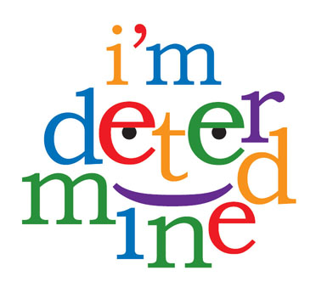

Support

What needs to happen to make it a Good Day?

* Ask for & save breakfast foods
* Same
* Get a one person seat
* Get all things together the night before
* See one every day
* Get water the night before and eat something I like
* Not get near them
* Once in a blue moon
* always
* Sometimes
* Almost always
* Just about every day
* Half the time
* Sometimes
* Breakfast at home
* Listen to music in shower
* Sitting alone on bus/stare out window
* Have all materials
* Positive contact with principals
* Have my water/drink mixes & good lunch
* To avoid people I don’t get along with

What happens on a Good Day?

Who can help me?

Now





* Grandma
* Me
* Me/bus driver
* Me/Grandma
* Me/Principal
* Me/ Grandma
* Ms. Greenfield

GoodDay

Does it happen now?

**My Good Day Plan**