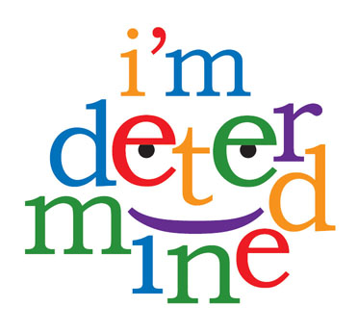

Support

What needs to happen to make it a Good Day?

What happens on a Good Day?

Who can help me?

Now





GoodDay

Does it happen now?

**My Good Day Plan**